**Appendix**

**Review of Internal Controls at Investment Managers**

**Aviva Investors**

“Report on Internal Controls” for the period 1 October 2015 to 30 September 2016.

Auditors: PricewaterhouseCoopers LLP

In the auditor’s opinion, in all material respects:

1. the description in sections D to G fairly presents the Service Organisation’s and the included Subservice Organisation’s investment management activities for institutional clients and pooled funds as designed and implemented throughout the period from 1 October 2015 to 30 September 2016;
2. the controls related to the control objectives stated in the description were suitably designed to provide reasonable assurance that the specified control objectives would be achieved if the described controls operated effectively throughout the period from 1 October 2015 to 30 September 2016 and customers applied the complementary user entity controls referred to in the scope paragraph of this assurance report; and
3. the controls tested which, together with the complementary user entity controls referred to in the scope paragraph of this assurance report, if operating effectively, were those necessary to provide reasonable assurance that the control objectives stated in the description were achieved, operated effectively throughout the period from 1 October 2015 to 30 September 2016.

**Of the 262 controls tested by the auditor, 7 exceptions were identified.**

These exceptions and the management responses are included at the end of this appendix.

**BlackRock Inc**

“Report on Controls at BlackRock Placed in Operation and Tests of Operating Effectiveness for Asset Management Services” for the period October 1, 2015 to September 30, 2016.

Auditors: Deloitte and Touche LLP

In the auditor’s opinion, in all material respects:

1. the description fairly presents the System that was designed and implemented throughout the period October 1, 2015 to September 30, 2016;
2. the controls related to the control objectives stated in the Description of the System were suitably designed to provide reasonable assurance that the control objectives would be achieved if the controls operated effectively throughout the period October 1, 2015 to September 30, 2016, and user entities applied the complementary user entity controls contemplated in the design of BlackRock’s controls throughout the period October 1, 2015 to September 30, 2016;
3. the controls tested, which together with the complementary user entity controls referred to in the scope paragraph of this report, if operating effectively, were those necessary to provide reasonable assurance that the control objectives stated in the Description of the System were achieved, operated effectively throughout the period October 1, 2015 to September 30, 2016.

**Of the 140 controls tested by the auditor, 5 exceptions were identified:**

1. **Page 76 – Control F.1.3** – For 1 of 40 securities selected for testing from a selection of Aladdin’s Surveillance Reports, DIG was unable to provide evidence of research and monitoring of missing data.

**Management Response:** Management confirmed that the exception related to delayed confirmation of an expected rating for a newly issued security. While evidence of continuous monitoring prior to resolution could not be provided for testing, the expected rating was correctly updated to Not Rated. Management noted that the exception identified had no impact to BlackRock-managed client accounts.

1. **Page 95 – P.1.2** – For 1 of 54 users with administrative access to the AutosysP job scheduler, D and T found that access was no longer authorised at the time of testing. Upon investigation, noted the administrative privileges were not updated upon the user’s transfer. Per inspection of the user’s account activity, D and T noted the user did not perform any administrative actions while the access was retained and further noted access for this user was remedied upon identification.

**Management Response:** Management confirmed that administrative access to the AutosysP job scheduler was retained following this user’s transfer to a new team. Management confirmed that the user did not perform any actions with this administrative access and removed access upon identification of the issue.

1. **Page 98 – Q.1.3** – For 1 of 56 individuals across transfers and terminations selected for testing , noted the transfer notification was not sent timely. Additionally, as per the testing performed for control Q.1.10, for 1 of 52 users with administrative access to an in-scope database server and 1 of 314 users with administrative access to the BlackRock network, D and T found that transfer notifications were not sent timely.

**Management Response:** Management has re-emphasised the importance of the quality and timeliness of HR notifications and are pursuing further automation of the transfer notification process to avoid similar issues in the future.

1. **Page 99 – Q.1.6** – As per the testing performed for control Q.1.10, of 182 users with administrative access to an in-scope database server, D and T found that for 2 users who transferred during the audit period, access was not updated in accordance with policy.

**Management Response:** Management confirmed that administrative access was retained following the users’ transfer. Management confirmed that the users did not perform any actions with this access, and removed access upon identification of the issue.

1. **Page 100 – Q.1.10** – For 5 separate users with access to IT systems (1 of 52 users with administrative access to an in-scope database server; 1 of 314 users with administrative access to the BlackRock network; and 3 of 182 users with administrative access to another in-scope database server), D and T found user access was no longer authorised at the time of testing . Upon investigation, noted in each instance the administrative privileges were not updated after the users’ transfer. Per inspection of the users’ activity, noted the users did not perform any administrative actions while the access was retained and further noted access for each of the users was remediated upon identification.

**Management Response:** Management confirmed that administrative access was retained following the users’ transfer. The users did not perform any actions with this access, which was removed upon identification of the issue. In addition, Management has re-emphasised the importance of the quality and timeliness of HR notifications and are pursuing further automation of the transfer notification process to avoid similar issues in the future.

**GMO**

“Report On GMO’s Description of its Advisory Services System and on the Suitability of the Design and Operating Effectiveness of Controls” for the period October 1, 2015 to September 30, 2016

Auditors: PricewaterhouseCoopers LLP

In the auditor’s opinion, in all material respects:

1. the description fairly presents the Advisory Services System that was designed and implemented throughout the period October 1 2015 to September 30 2016;
2. the controls related to the control objectives of GMO stated in the description were suitably designed to provide reasonable assurance that the control objectives would be achieved if the controls operated effectively throughout the period October 1 2015 to September 30 2016 and user entities applied the complementary user entity controls contemplated in the design of GMO’s controls throughout the period October 1 2015 to September 30 2016;
3. the controls of GMO tested, which together with the complementary user entity controls referred to in the scope section of this report, if operating effectively, were those necessary to provide reasonable assurance that the control objectives stated in the description were achieved, operated effectively throughout the period October 1 2015 to September 30 2016.

**Of the 147 controls tested by the auditor, 1 exception was identified:**

1. **Page 58 – Control 2a** – Re US and UK operational controls for 1 of 40 client account update requests selected for testing, the client’s request was not processed timely. PwC selected 24 additional client account update requests and noted no additional exceptions.

**Management Response:** Management acknowledges the finding. Management has reinforced the importance of timely communication of client account changes to the Client Operations team for processing and performed additional training.

**Oldfield Partners LLP**

“AAF 01/06 Assurance Report on Internal Controls” for the period 1 July 2015 to 30 June 2016

Auditors: Deloitte LLP

In the auditor’s opinion, in all material respects:

1. the description on pages 10 to 38 fairly presents the control procedures of Oldfield Partners LLP’s investment management services that were designed and implemented throughout the period 1 July 2015 to 30 June 2016;
2. the controls related to the control objectives stated in the description on pages 10 to 38 were suitably designed to provide reasonable assurance that the specified control objectives would be achieved if the described controls operated effectively throughout the period 1 July 2015 to 30 June 2016; and
3. the controls that we tested were operating with sufficient effectiveness to provide reasonable assurance, that the related control objectives stated in the description were achieved throughout the period 1 July 2015 to 30 June 2016.

**Of the 154 controls tested by the auditor, 1 exception was identified.**

1. **Page 31 – Control 7.2.4** – For a sample of 1 out of 2 new joiners there was no documented approval from Head of Operations for access to Eagle IAS.

Further investigation with Head of Operations revealed that it was appropriate for the new joiner to have access.

**Pantheon**

“Type II Report on Controls Placed in Operation Relating to Investment Advisory and Management Activities” for the period from 1 October, 2015 to 30 September, 2016

Auditors: KPMG LLP

In the auditor’s opinion, in all material respects:

1. the Description fairly presents the Investment Advisory and Management Activities system as designed and implemented throughout the period from 1 October 2015 to 30 September 2016;
2. the controls related to the control objectives stated in the Description were suitably designed throughout the period from 1 October 2015 to 30 September 2016; and
3. the controls tested, which were those necessary to provide reasonable assurance that the control objectives stated in the Description were achieved, operated effectively throughout the period from 1 October 2015 to 30 September 2016.

**Of the 112 control objectives tested by the auditor, 1 exception was identified:**

1. **Page 50 – Control MF21** – For 1 of 25 samples selected, it was noted that the client fee calculation was not consistent with the relevant legal documentation.

**Management Response:** An error was discovered internally identifying an incorrect fee rebate calculation for a Client. Immediately on discovery the Client was contacted and the amount owing to them was repaid. A detailed review of our revenue processes, controls and calculations was carried out as a result. A report covering the issue and remedial actions was circulated by the CFO to the PB and to AMG. Management are comfortable with the investigation and remedial actions which include a higher level of review.

**Record Currency Management Ltd**

“Report on Internal Controls (AAF 01/06)” for the period 1 April, 2015 to 31 March, 2016.

Auditors: Grant Thornton UK LLP

The auditors confirmed that in all material aspects:

1. the accompanying report by the directors describes fairly the control procedures that relate to the control objectives referred to above which were in place as at 31 March 2016;
2. the control procedures described on pages 11 to 70 are suitably designed such that there is reasonable, but not absolute, assurance that the specified control objectives would have been achieved if the described control procedures were complied with satisfactorily; and
3. the control procedures that were tested, as set out in the body of this report, were operating with sufficient effectiveness for us to obtain reasonable, but not absolute, assurance that the related control objectives were achieved in the period 1 April 2015 to 31 March 2016.

**Of the 146 controls tested by the auditor, 1 exception was identified.**

1. **Page 65 – Control 3.1.6** – It was noted that in one instance write access was granted to more users than had a business need for such access and the spreadsheet formulae were not locked.

Corrective action has been taken by Management. Subsequent observation of user access confirmed that the relevant spreadsheet had been moved to a restricted area on the network and password protected.

**Standard Life Investments**

“Internal Controls Report” for 1 October 2014 to 30 September 2015

Auditors: PricewaterhouseCoopers LLP

In the Auditor’s opinion, in all material respects:

1. the description on pages 23 to 117 fairly presents the in-scope investment management services that were designed and implemented throughout the period from 1 October 2015 to 30 September 2016;
2. the controls related to the control objectives stated in the description were suitably designed to provide reasonable assurance that the specified control objectives would be achieved if the described controls operated effectively throughout the period from 1 October 2015 to 30 September 2016 and clients applied the complementary client controls referred to in the scope paragraph of this report; and
3. the controls tested which, together with the complementary client controls referred to in the scope paragraph of this report, if operating effectively, were those necessary to provide reasonable assurance that the control objectives stated in the description were achieved, operated effectively throughout the period from 1 October 2015 to 30 September 2016.

**Of the 326 controls tested by the auditor, 11 exceptions were identified:**

These exceptions and the management responses are included at the end of this appendix.

**State Street Global Advisors**

“Service Organisation Control Report” July 1, 2015 – June 30, 2016

Auditors: Ernst & Young LLP

In the auditor’s opinion, in all material respects:

1. the Description fairly presents SSGA’s Investment Advisory System Applicable to the Processing of Client Transactions that was designed and implemented throughout the period July 1, 2015 to June 30, 2016;
2. the controls related to the control objectives stated in the Description were suitably designed to provide reasonable assurance that the control objectives would be achieved if the controls operated effectively throughout the period July 1, 2015 to June 30,2016 and if user entities applied the complementary user entity controls contemplated in the design of SSGA’s controls and if State Street’s Information Technology and Global Security divisions applied the controls contemplated in the design of State Street’s controls throughout the period July 1, 2015 to June 30, 2016;
3. the controls of SSGA tested, which, together with the complementary user entity controls and States Street’s Information Technology and Global Security divisions’ controls referred to in the scope paragraph of this report if operating effectively, were those necessary to provide reasonable assurance that the control objectives stated in the Description were achieved, operated effectively throughout the period July 1, 2015 to June 30, 2016.

**Of the 160 controls tested by the auditor, 3 exceptions were identified:**

1. **Control 1.2** – Out of a combined sample of 88 new or amended funds/accounts, for 1 of 26 new or amended funds/accounts selected for testing in the UK, the English version of the contract used to update extraction forms included a reference to an incorrect regulatory requirement due to an inaccurate translation from the original contract which was identified and corrected by SSGA in advance of trading implementation.

**Management Response:** Management acknowledges that for 1 out of 26 new or amended fund/accounts serviced in the UK selected for testing included a reference to an incorrect regulatory requirement due to an inaccurate translation from the original contract which was identified and corrected in advance of trading implementation. Management has enhanced the process whereby translations of all non-English client account contracts will be outsourced to a third party firm.

1. **Control 12.1** – For 1 out of 40 new fee schedules selected for testing, the Fee Extraction Form was not prepared and therefore the new account was not set up on RMS.

**Management Response:** Management acknowledges that for 1 of 40 new fee schedules selected for testing, the Fee Extraction Form was not prepared and therefore the account was not set up on RMS. Management notes that the fee schedule for the new account was subsequently set up and reflected accurately in the RMS application. Management has reinforced with the appropriate personnel the requirement to review the mailbox at the end of each day to make sure that all new/amended accounts have been identified and processed by the billing team. The Fund Not Set Up compensating review control is in place to prevent significant errors and omissions (refer to control 12.2).

1. **Control 12.1** – For 2 out of 36 amended fee schedules selected for testing, the Fee Extraction Form was not prepared and reviewed and the amendment was not made on RMS.

**Management Response:** Management acknowledges that for 2 out of 36 amended fee schedules selected for testing, the Fee Extraction Form was not prepared and therefore the amended fee rates reflected on RMS were not updated. A further review of contract amendments back to the beginning of the year was performed to ensure no further executed amended contracts were missed. Through this review 1 additional item was found. Management notes that the fee schedules for the amended accounts were subsequently set up and reflected accurately in the RMS application. Management has reinforced with the appropriate personnel the requirement to review the mailbox at the end of each day to make sure that all new/amended accounts have been identified and processed by the billing team.

**Aviva Investors**

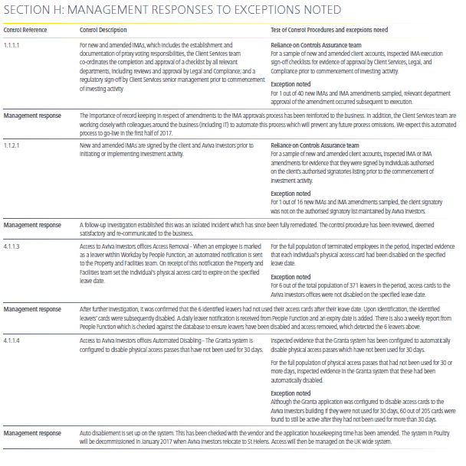

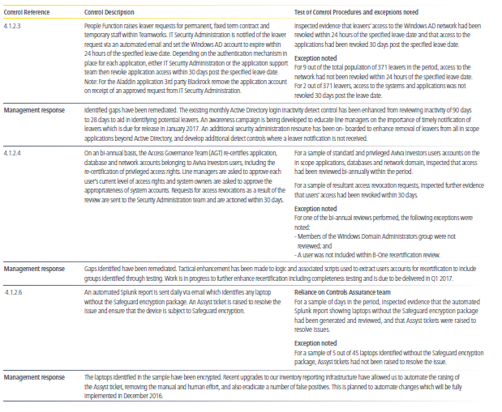

**Standard Life**

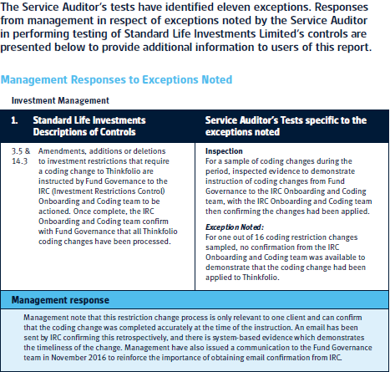

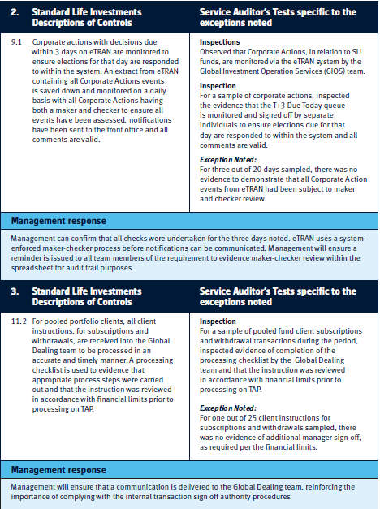

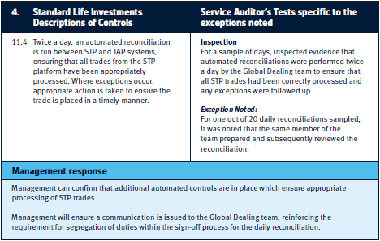

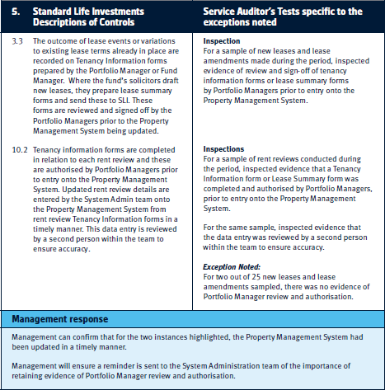

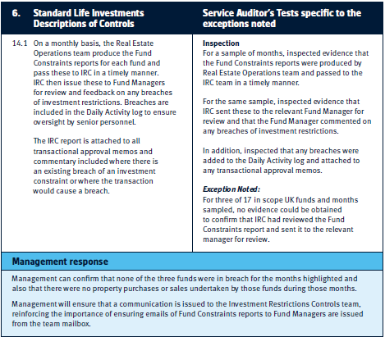

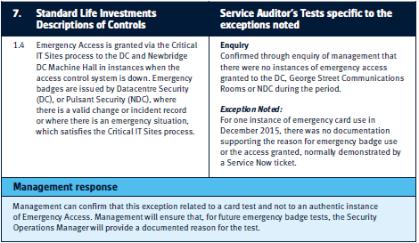

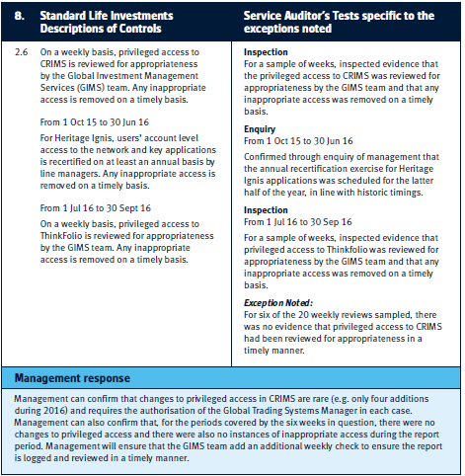

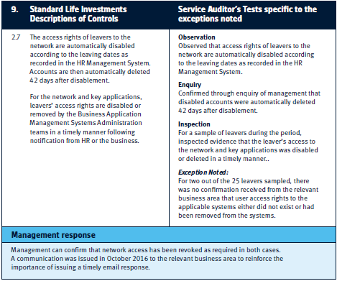

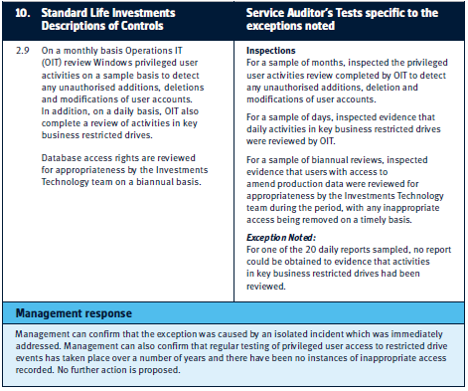

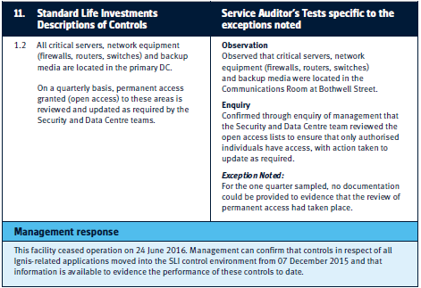

**Table showing number of controls tested by each manager and the number of exceptions as reported to Committee in 2015, 2016 and 2017**

